RDHL-200HX Portable Loop Resistance Tester

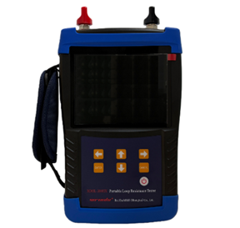
RDHL-200HX Portable Loop Resistance Tester is a high-precision, digital switch detection instrument carefully developed by our company to leverage our technological advantages. This instrument can be powered by lithium batteries, has a small size, light weight, handheld operation, and is easy to carry. It is widely used to measure the contact resistance, loop resistance of various switches and electrical appliances, and the contact resistance of cables, wires and welds. The instrument has accurate measurement data and stable performance, meeting the requirements of on-site high-voltage switch maintenance of electric power and power supply departments and loop resistance test of high-voltage switch factory.

- Product features

- Powered by lithium batteries, it can perform more than 500 consecutive tests on a single charge, and the testing process is simple and convenient.
- Multiple current options of 200A/150A/100A/80A/50A/30A make testing more flexible.
- During 100A testing, the maximum testing time can reach 60 seconds, meeting various on-site applications.
- It has complete protection functions such as open circuit protection and overheating protection.
- The 5.6-inch ultra large industrial grade high brightness color LCD screen displays clearly and visibly even in strong sunlight.
- It has both local storage and USB storage for convenient data storage.
- External printer (optional) for easy on-site printing of data.
- Product specifications and technical parameters
- Test current: 30A, 50A, 80A, 100A, 150A, 200A
- Range: 0 ~ 20mΩ (30A) 0 ~ 10mΩ (50A) 0 ~ 8mΩ (80A)
0 ~ 5mΩ (100A) 0 ~ 2mΩ (150A) 0 ~ 1mΩ (200A)
- Resolution: minimum 0.1µΩ
- Accuracy: ± (0.5%rdg + 1µΩ)
- Testing time: Fast, 10s, 20s, 30s, 40s, 50s, 60s (Timing test is only applicable to 30A, 50A, 80A, 100A)
- Power: ≤500W
- Port: RS232, charging, USB
- Working mode: constant current limited voltage, output voltage about 2V
- Power supply: Rechargeable lithium batteries; Charger input 100-240VAC, 50Hz/60Hz.
- Service temperature: -10 ~ 50℃
- Relative humidity: ≤ 90%, no condensation

